Spring Walk – Lupus Awareness
Jack Muller Danie Uys Park, Bellville, Cape Town
02 September 2023

By Hayley Leandra February

I know two people in our church who suffer – some seasons more terribly than others – from lupus. That’s how I found myself at this event to raise people’s awareness of the autoimmune disease and its impact on sufferers (warriors from hereon in) and their loved ones. And what a wealth of knowledge did I pick up – and what respect did these warriors gain with this exposure!

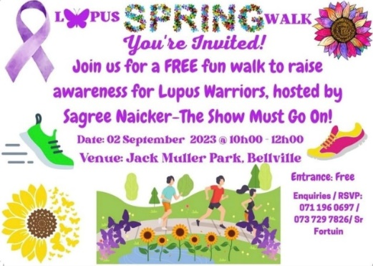
The invitation

It was a cold and rainy Saturday morning in Cape Town. Only the very brave or very foolish would venture out to face the elements that day. I met no fools; only some brave warriors facing life as we know it in 2023 plus extraordinary battles for wellbeing.

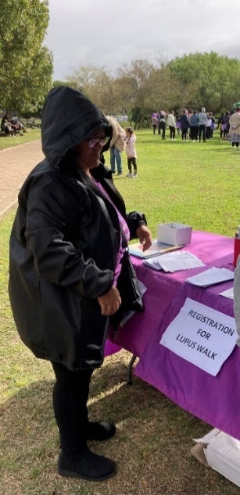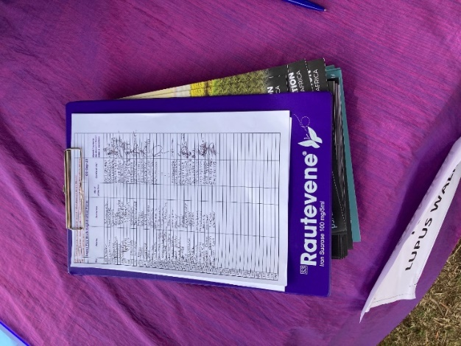
Reception: for registering for the event

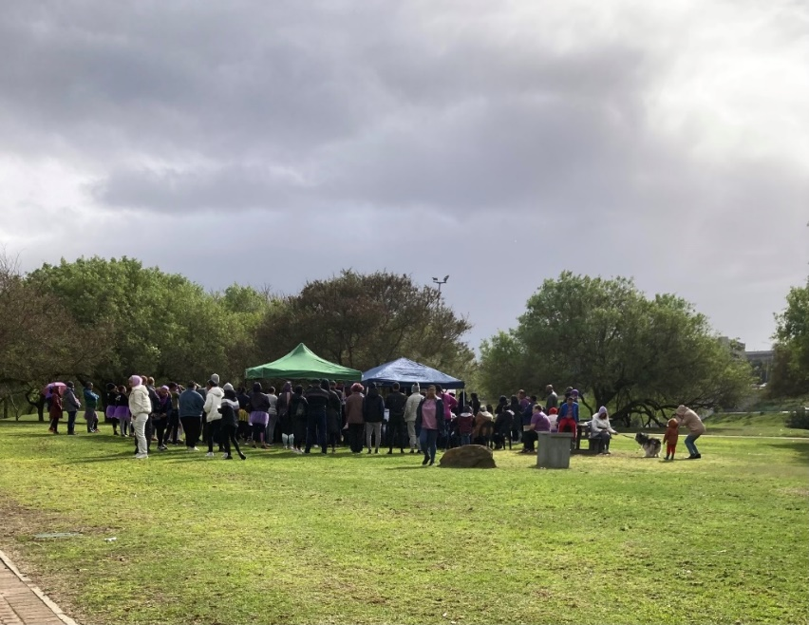

We were met with reception tables at the entrance to the park – for registering for the walk. We then walked a short distance to where gazebos and tables had been set up. We were welcomed by the MC who introduced the first speaker who read excerpts from The Show Must Go On by Sagree Naicker, wearer of many hats: lupus warrior, wife, mom, daughter, sibling, RN, author – and event organiser.

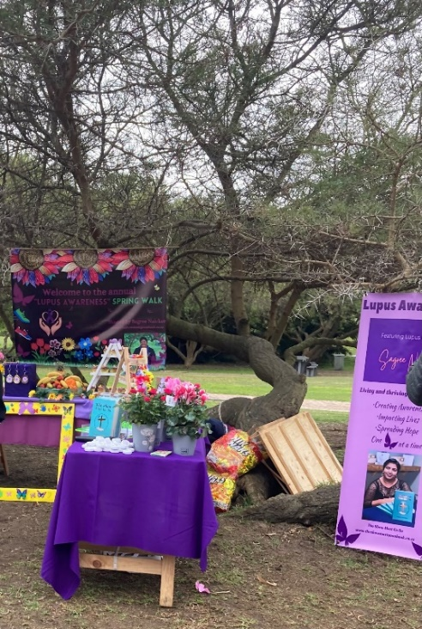

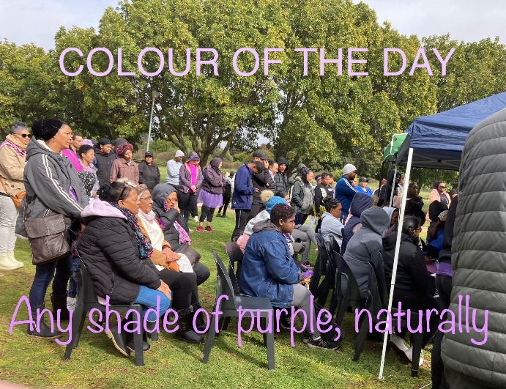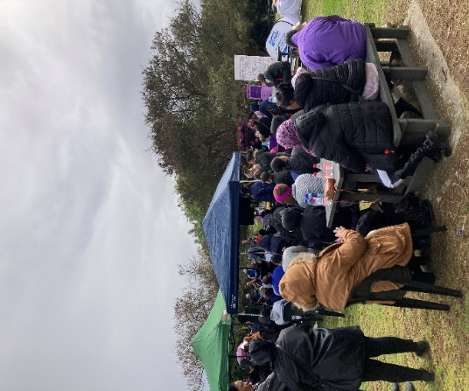
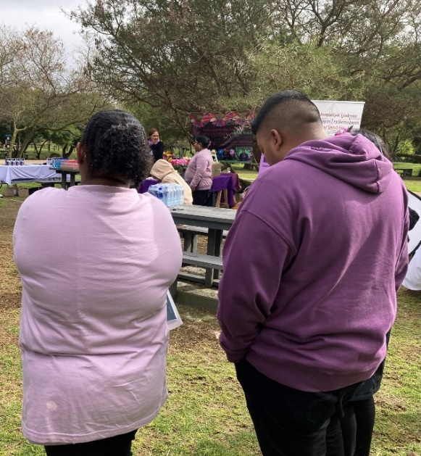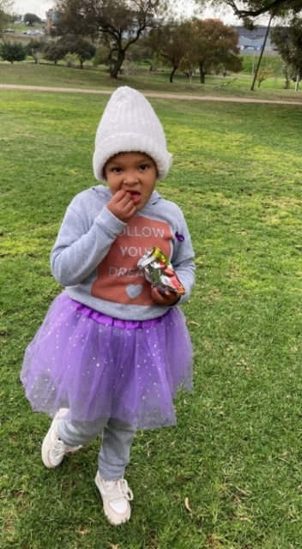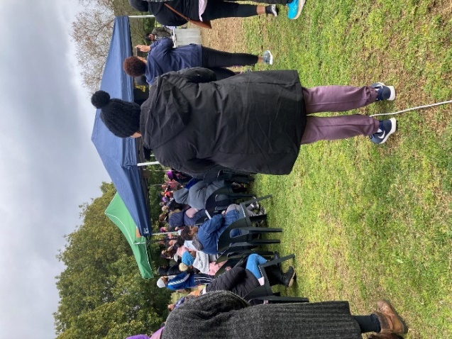
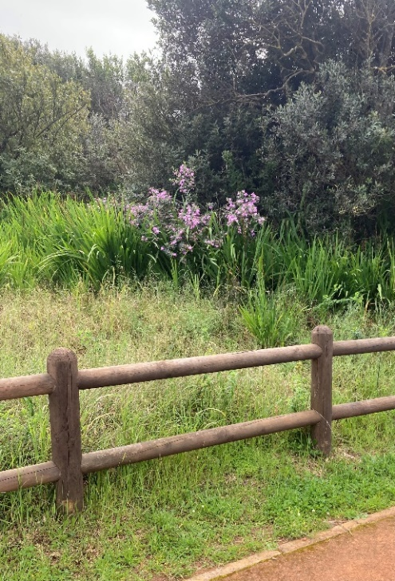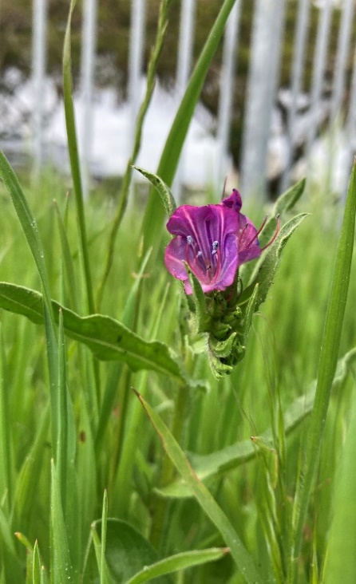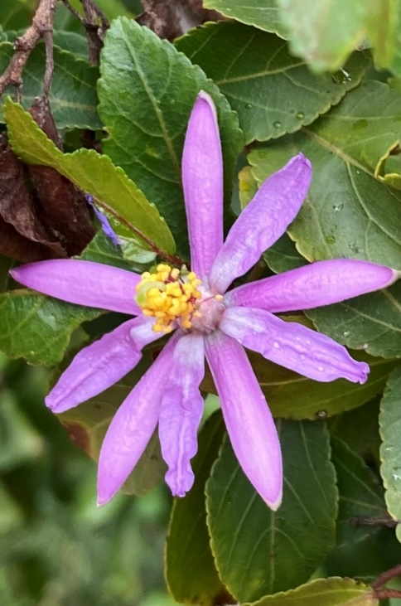
As the pic says, the colour of the day was purple – any shade of it – and nature followed suit.

There was a hint of togetherness and joy in the air. Young and old didn’t allow the dismal weather to mess with their purple or their sparkle! There were many purples, lavenders, lilacs, violets, and mauves. Nature got the memo too and didn’t disappoint. One lupus warrior even sported a flower in her hair. The event was even graced by a joy-filled purple butterfly. (Apparently, butterflies are huge for lupus – not only for their fragility but also because of the butterfly-shaped rash that appears on the cheeks of lupus warriors during a flare-up.) Those gathered smiled more readily, opened up more easily. It was good to be there. It must be said that while the lupus warrior is the one stricken with the disease, others walk with them. This was evidenced by the number of loved ones who gathered in support.

Lupus warriors, Marvellous Marcia and Positive Patricia, shared their journeys with the disease.

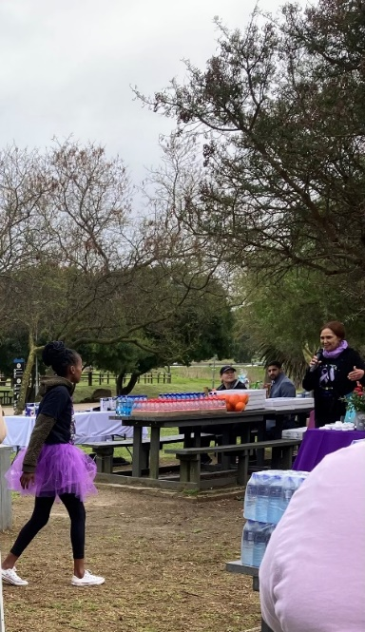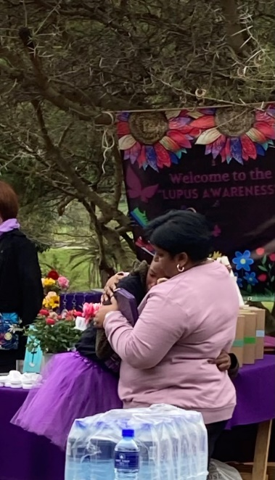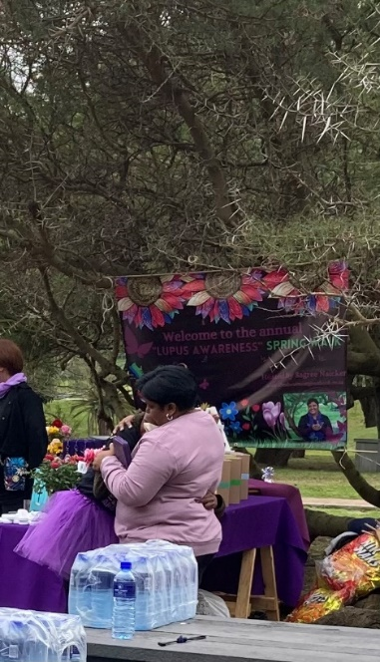
Marcia (15) stepping up to the mic to share her story – and being hugged by Sagree thereafter

Marcia’s journey, as shared before the spring walk

My name is Marcia and I come from Ceres. I am 15 years old. I have had lupus for 5…no 3….no 2 years (speaker’s nerves). I discovered I had lupus on 20 December 2020.

The Sunday I had gone to church with a friend and her parents, after I’d eaten breakfast. I told my friend that I wasn’t feeling well….that I felt nauseous. I thought it was the salty breakfast I’d had. But I sat in church and the spoke the Word and the blessing over us. After that, I went home. There things went nuts. I threw up. My mother said we’d go to the clinic on Monday, as I’d been losing weight and was sleepy all the time. I told her, “I can’t anymore.” She assured me we’d go find out what was wrong with me.

At the clinic, they suspected tuberculosis (TB) and gave me tablets so that I could pick up weight. I told my mother that I wasn’t going to proceed, as I’d received medication to strengthen me, but she wanted us to persist, as she saw no changes in my symptoms.
I went back to the clinic on Tuesday and they confirmed that I didn’t have TB. And so it went on… My mother was most upset and accused them of not doing their work properly – and warned that she was going to take me to the day hospital.

A whole year and a bit later, on 15 January 2021, my mother and I went to hospital. After tests, they suspected something was wrong with my kidneys, but couldn’t be sure. The wrote a letter and sent me to the ER. There they took my weight, drew blood and all the other stuff. The also wanted to check my sugar levels. They had me on an IV drip – and then I got despondent, crying out to my mother, “Why must I go through such a lot of stuff?” She assured me that I would be alright. PAUSE.

The Friday night – 12 AM – they sent me to another hospital. They immediately admitted me to ICU. They could see I was struggling to breathe and suspected some heart problem. They told my mom that I wouldn’t be able to go home soon, as they wanted to do more tests and might have to schedule an operation. After a week in High Care, I started coughing up blood – and was sent to ICU for the second time. They discovered I had water on my heart, which they treated with medication. Back to High Care. I told my mom that I was hungry and wanted something solid to eat – I yearned for some vegetables. She went out to the fruit and veg stalls to get me some veggies, including cucumber. Just after I’d eaten the cucumber, I remember telling her that I couldn’t breathe. Third time: back to the ICU. This time they suspected that the cucumber got lodged in my throat. Apparently, I couldn’t eat cucumber! At this point, my mother got despondent and wanted to go home. Doctors were willing to give her a bus ticket to go home, but she refused. She was going to see me through this. They assured her that I would get better with a low salt diet.

God turned me away from death for the third time. I just want to say that lupus is not an easy disease. Apparently, many have died from it. I am grateful to God for carrying me through it and for keeping me strong. I am a strong young woman. I keep taking my meds and fight to live. And the doctors – thank you.


Lupus sufferer? Not me! I am a lupus warrior

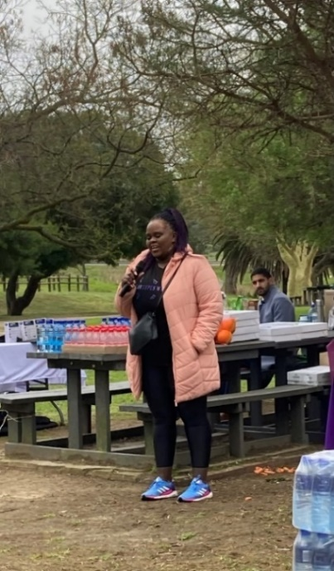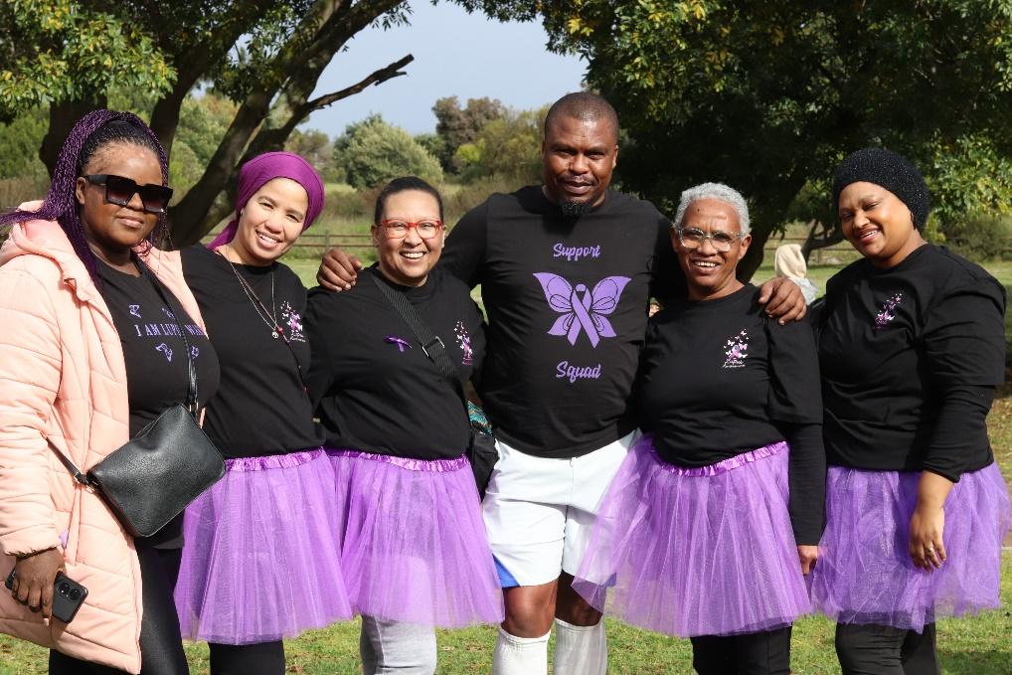
Patricia inspiring others with her story – and with some participants

Patricia then shared her journey. Her story touched hearts, as did Marcia’s. Of the many inspiring comments, one stood out – her determination to be positive no matter what. That positivity oozed through, not only with her words, but with her smile and the way she shared her story. (Editor’s Note: we hope to have the details of her inspiring journey in forthcoming editions.)

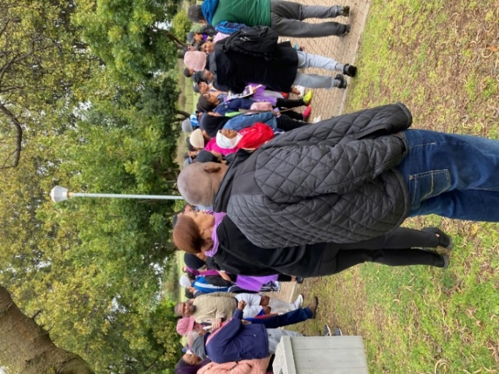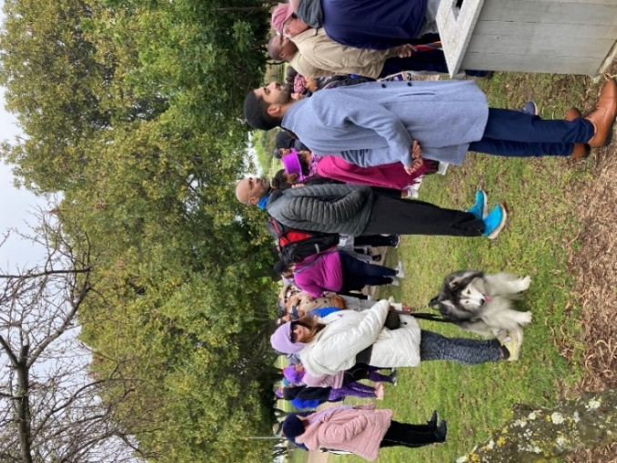
Walkers getting ready for the walk, including our mascot (the husky) and a medic (blue sneakers)

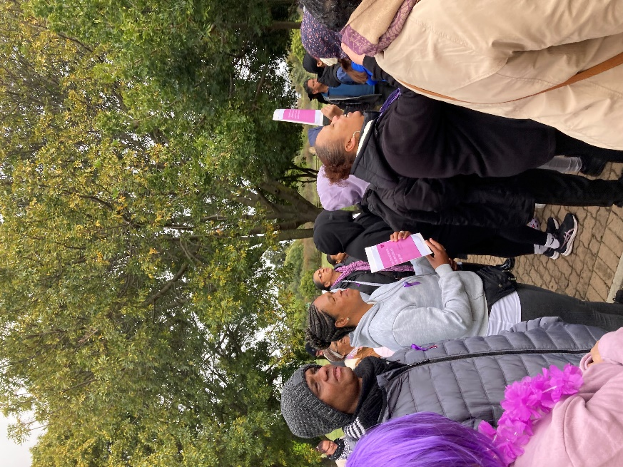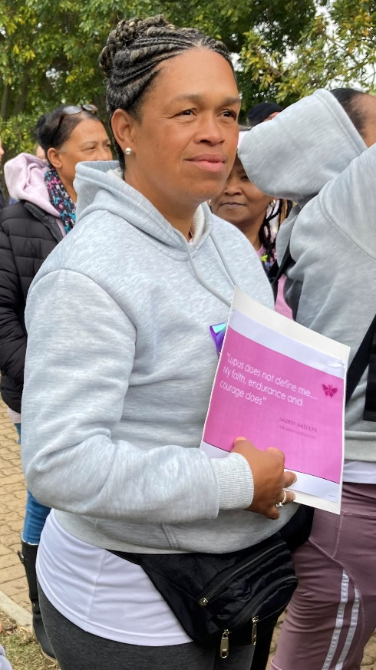
Sign says: LUPUS DOES NOT DEFINE ME; MY FAITH, ENDURANCE AND COURAGE DOES

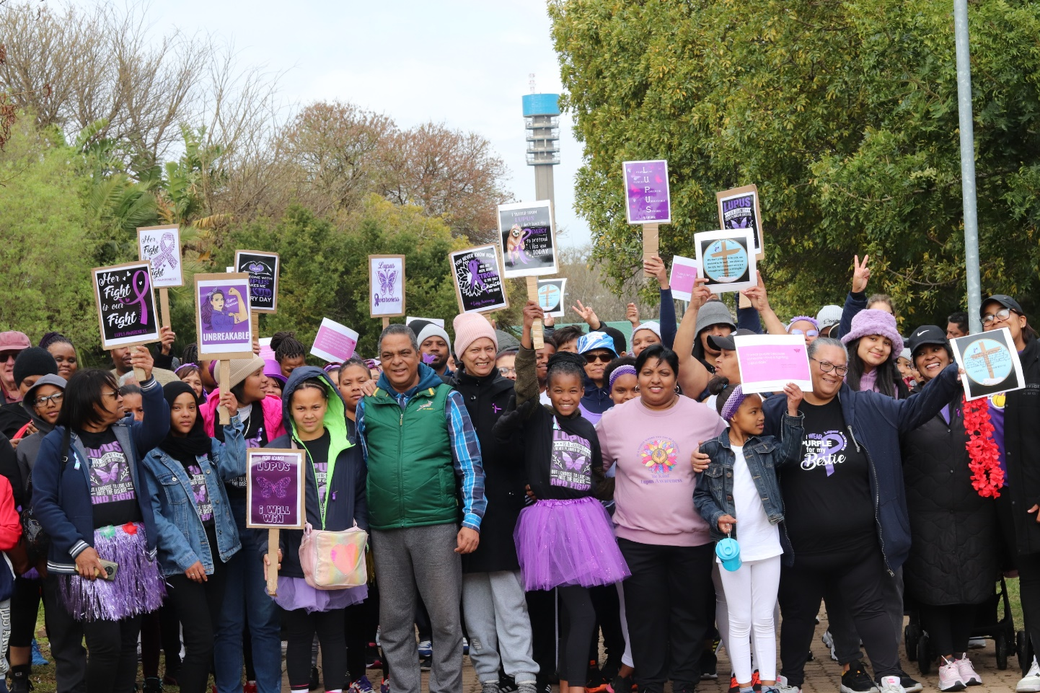
Walkers held up signs as the walk started

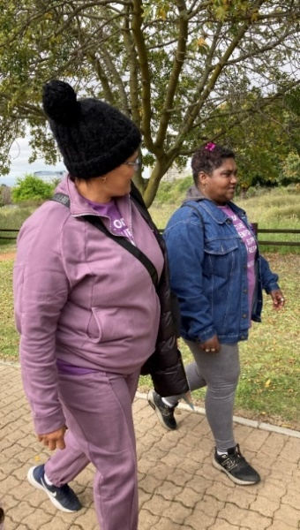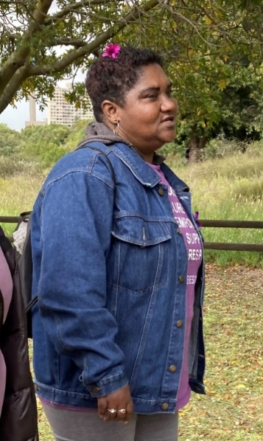
Two warriors were even overheard comparing notes on the effects of the disease on their bodies

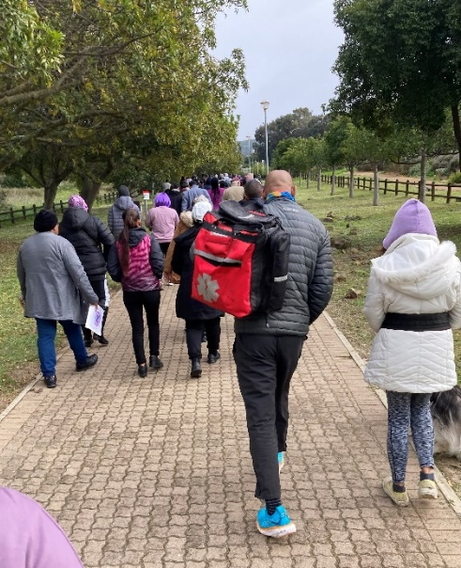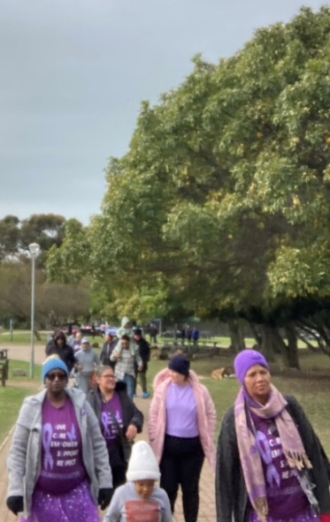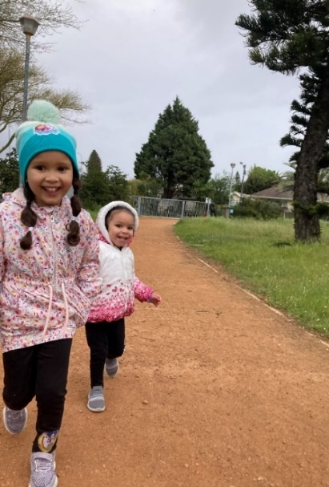

Some didn’t appear to get the memo: spring walk not spring run. Despite the rain here and there and the heartrending sharing, this spring walk was not a sad event. It wasn’t about the snacks for the kiddies or the lucky draws. There was a spirit of warmth and support and love – of victory, even! You’ve got this. We’ve got you. Others walk this journey with you; you are not alone. You can do this.

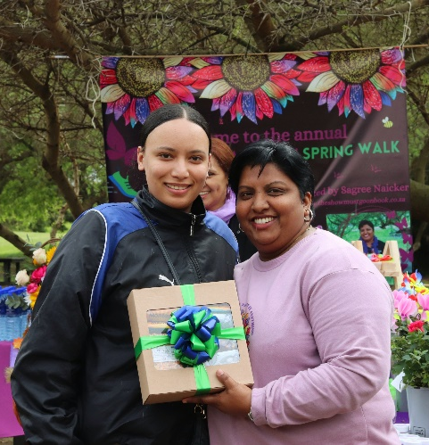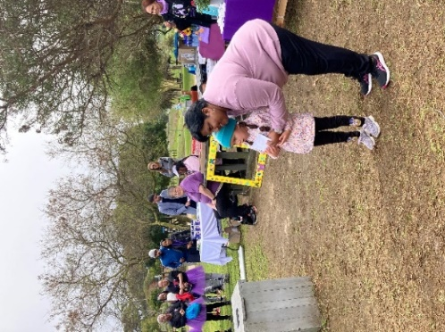
Some winners of the lucky draws

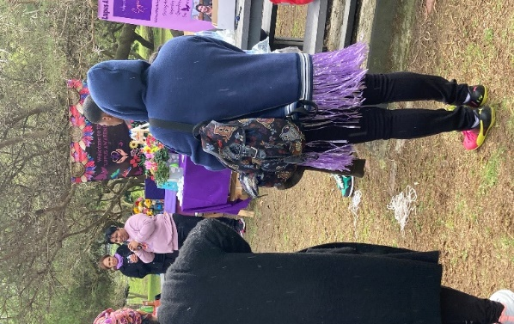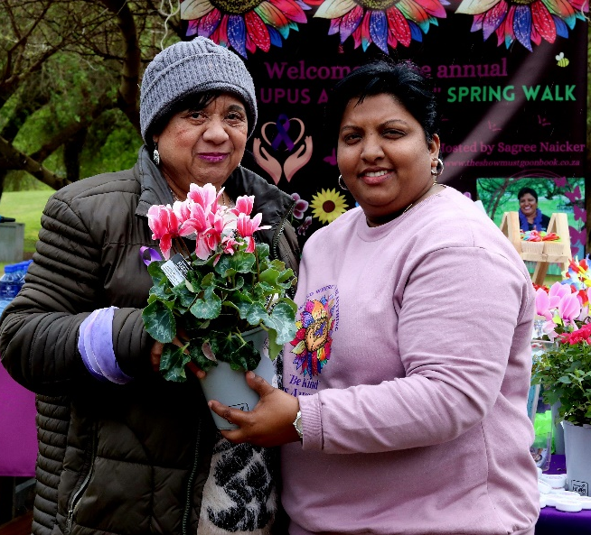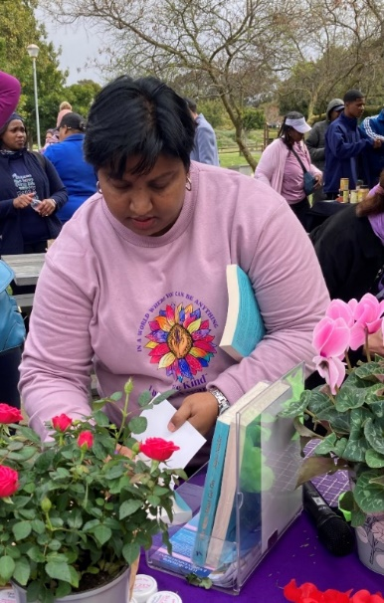
Sagree thanking participants and being thanked – and then signing copies of her book after the event

Having done more than what the spring walk gathering set out to do (raise consciousness, touch hearts and inspire others), here is an insightful quote from The Show Must Go On, which sums up the confounding journey of a lupus warrior:

Looking from the outside in, you can never understand it. Standing on the inside looking out, you can never explain it.

Perhaps these words best encapsulate what Marcia tried to say, what Patricia stands for, what Sagree shared in her book – and all those other journeys walked by lupus warriors.

Editor’s Note: The Show Must Go On by Sagree Naicker (Reach Publishers) is available via Amazon and on Kindle. It can also be ordered at https://www.theshowmustgoonbook.co.za/contact/. Sagree can be contacted via email at theshowMGN@gmail.com or via Instagram at @the_show_must_go_on79.

Editor’s Note: this is just a taste of what awaits us where lupus awareness is concerned. We hope to share other warriors’ journeys in upcoming issues of Karoo Sisters Magazine. Please contact us if you wish to share your story with empathetic hearts.

